PIZZA SALES SQL QUERIES
A)KPIS
- Total Revenue
select sum(total_price) as Total_Revenue
from pizza_sales$;
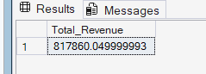

- Average Order Value
select sum(total_price)/count( distinct order_id)as average
from pizza_sales$;
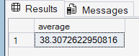

- Total Pizza Sold
select sum(quantity) Total_Pizza_sold from pizza_sales$;
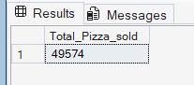

- Total Orders
select count(distinct order_id) as Total_orders from pizza_sales$;
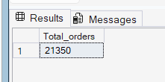
- Average Pizzas Per order
select cast((sum(quantity)/count(distinct order_id)) as decimal(10,2)) as Average_pizza from pizza_sales$;
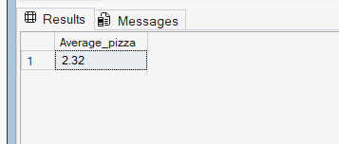

B)CHART REQUIREMENTS
- Daily Trend for Total Orders
select datename(dw , order_date) as days, count(distinct order_id) as daily_order
from pizza_sales$
group by datename(dw , order_date);
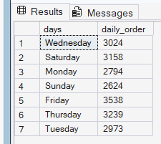

- Monthly Trend for Total Orders
select datename(Month , order_date) as Month,datepart(MONTH , order_date), count(distinct order_id) as daily_order
from pizza_sales$
group by datename(MONTH , order_date),datepart(MONTH , order_date)
order by daily_order desc;
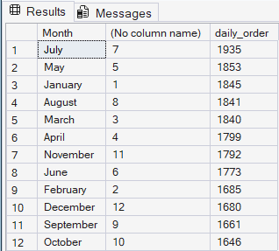
- Percentage of sales by Pizza Category
select new.pizza_category , new.total_sales , ((new.total_sales/tt.total)*100) as Percentage
from
(select pizza_category ,sum(total_price) as total_sales
from pizza_sales$
group by pizza_category) as new, //these two are cross producting because we have not joined them
(select sum(total_price) as total from pizza_sales$) as tt
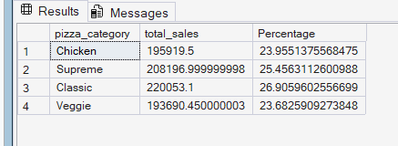
OR
select pizza_category , sum(total_price) as total_pizzasales ,
sum(total_price) *100/(select sum(total_price) from pizza_sales$) as
percentage
from pizza_sales group by pizza_category ;
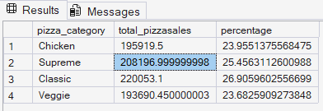

- Percentage of Sales by Pizza Size

select pizza_size , sum(total_price) as total_pizzasales ,
Cast(sum(total_price) *100/(select sum(total_price) from pizza_sales$)As decimal(10,2)) as percentage
from pizza_sales$
group by pizza_size
order by percentage;

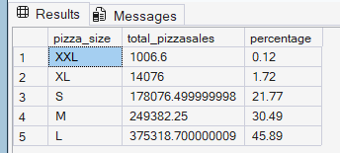

- Total Pizzas Sold by Category

select pizza_category , sum(quantity) as total_pizzas_sold
from pizza_sales$
group by pizza_category

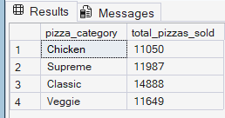

- Top 5 best sellers by
Revenue
select top 5 pizza_name , sum(total_price) as Total_revenue
from pizza_sales$
group by pizza_name
order by Total_revenue desc
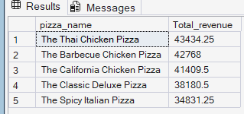

Quantity

select top 5 pizza_name , sum(quantity) as Total_Quanity
from pizza_sales$
group by pizza_name
order by Total_Quanity desc

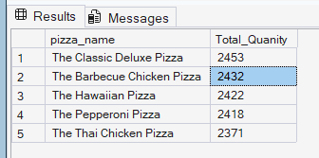

Total Orders

select top 5 pizza_name , count(distinct order_id) as Total_order
from pizza_sales$
group by pizza_name
order by Total_order desc

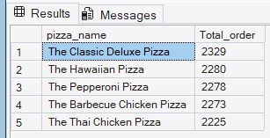

- Bottom 5 sellers
Revenue

select top 5 pizza_name , sum(total_price) as Total_Revenue
from pizza_sales$
group by pizza_name
order by Total_Revenue
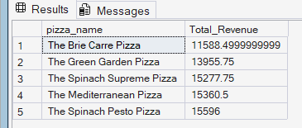
Total Quantity

select top 5 pizza_name , sum(quantity) as Total_Quanity
from pizza_sales$
group by pizza_name
order by Total_Quanity

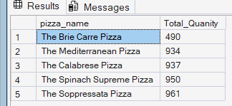
Total Order

select top 5 pizza_name , count(distinct order_id) as Total_order
from pizza_sales$
group by pizza_name
order by Total_order

